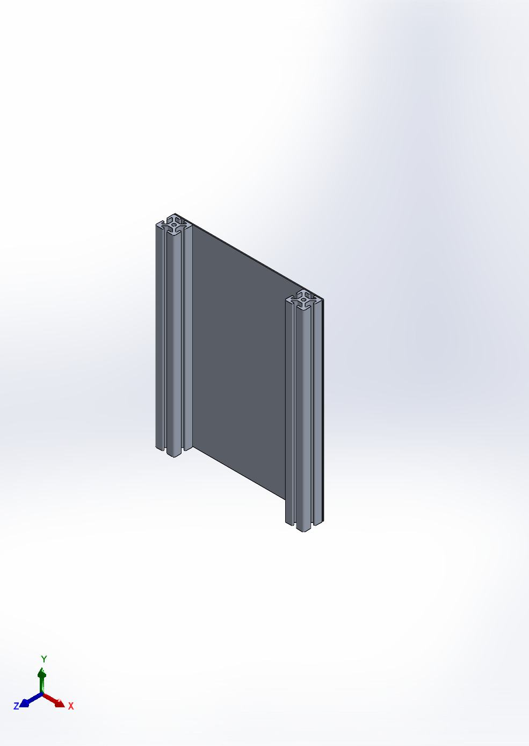 | Simulation of case 1 4bolts 2mm  Date: Monday, 26 January 2026  Designer: Solidworks  Study name: Static 1  Analysis type: Static  Table of Contents  Description 1  Assumptions 2  Model Information 3  Study Properties 6  Units 6  Material Properties 7  Loads and Fixtures 8  Connector Definitions 9  Interaction Information 10  Mesh information 11  Sensor Details 12  Resultant Forces 13  Beams 13  Study Results 14  Conclusion 17

Description
No Data

Assumptions

Model Information

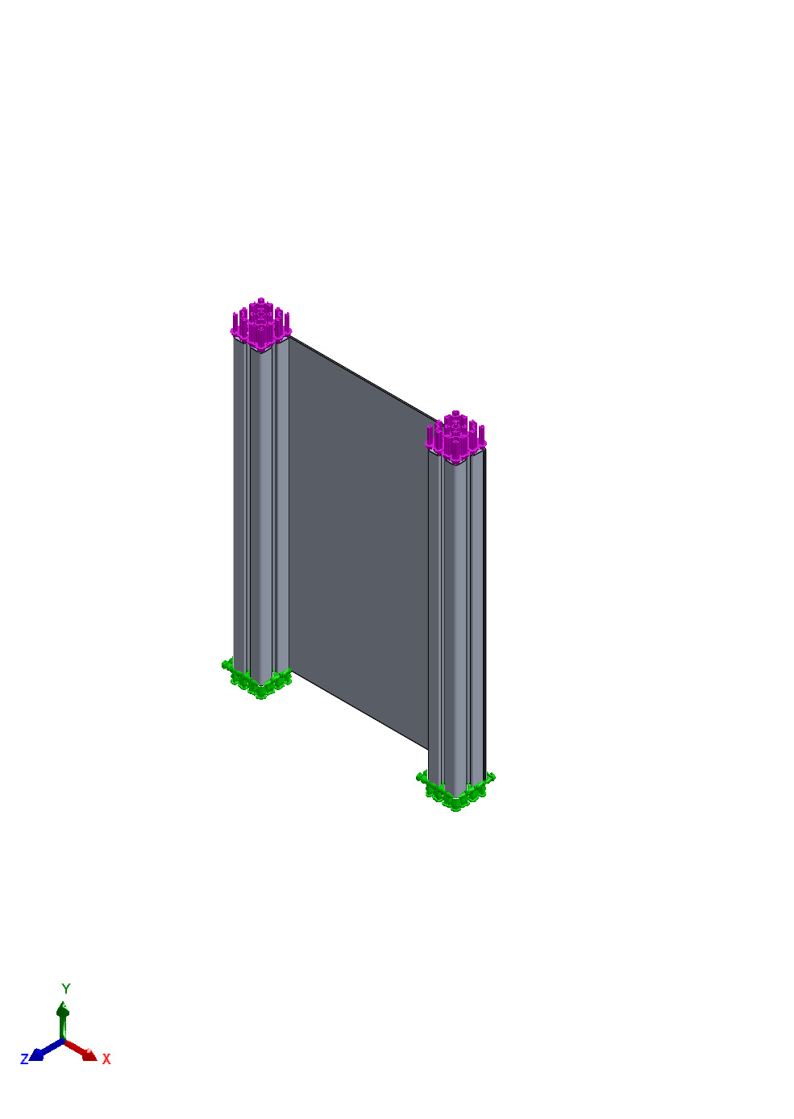
Model name: case 1 4bolts 2mm
Current Configuration: Default
Solid Bodies
Document Name and Reference | Treated As | Volumetric Properties | Document Path/Date Modified
Split Line1  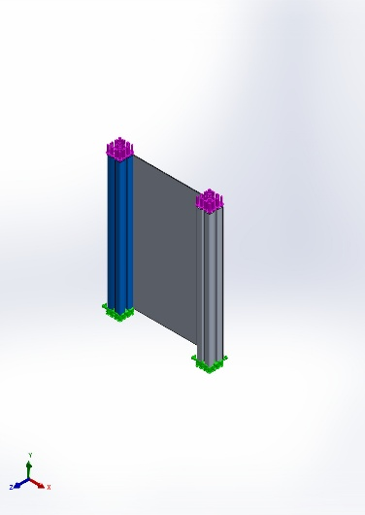 | Solid Body | Mass:0.932173 kg  Volume:0.000345249 m^3  Density:2,700 kg/m^3  Weight:9.13529 N | C:\Users\ASUS\OneDrive - National University of Singapore\Downloads\NUS\MODULES\Year 2 Sem 2 2024\EG3301R Ideas to Proof-of-Concept\2.0\CDE4301 BoxBunny2 - General\CAD Model\Final\Bottom Assembly\v3\support plate sim\4040_sim.SLDPRT  Jan 26 00:49:49 2026
Split Line1  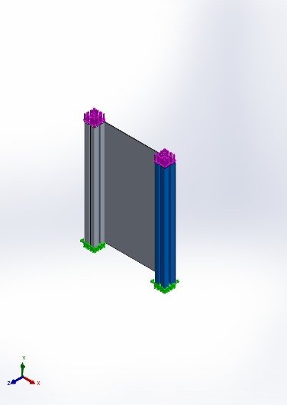 | Solid Body | Mass:0.932173 kg  Volume:0.000345249 m^3  Density:2,700 kg/m^3  Weight:9.13529 N | C:\Users\ASUS\OneDrive - National University of Singapore\Downloads\NUS\MODULES\Year 2 Sem 2 2024\EG3301R Ideas to Proof-of-Concept\2.0\CDE4301 BoxBunny2 - General\CAD Model\Final\Bottom Assembly\v3\support plate sim\4040_sim.SLDPRT  Jan 26 00:49:49 2026
Split Line1  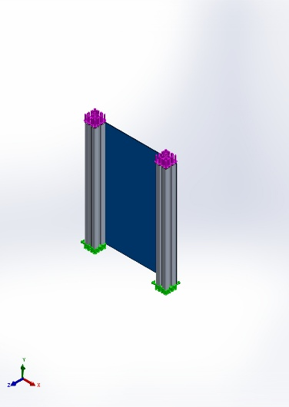 | Solid Body | Mass:0.668514 kg  Volume:0.000247598 m^3  Density:2,700 kg/m^3  Weight:6.55144 N | C:\Users\ASUS\OneDrive - National University of Singapore\Downloads\NUS\MODULES\Year 2 Sem 2 2024\EG3301R Ideas to Proof-of-Concept\2.0\CDE4301 BoxBunny2 - General\CAD Model\Final\Bottom Assembly\v3\support plate sim\support plate_sim_4bolts_2mm.SLDPRT  Jan 26 00:33:57 2026

Study Properties
Study name | Static 1
Analysis type | Static
Mesh type | Solid Mesh
Thermal Effect: | On
Thermal option | Include temperature loads
Zero strain temperature | 25 Celsius
Include fluid pressure effects from SOLIDWORKS Flow Simulation | Off
Solver type | Automatic
Inplane Effect: | Off
Soft Spring: | Off
Inertial Relief: | Off
Incompatible bonding options | Automatic
Large displacement | Off
Compute free body forces | On
Friction | Off
Use Adaptive Method: | Off
Result folder | SOLIDWORKS document (C:\Users\ASUS\OneDrive - National University of Singapore\Downloads\NUS\MODULES\Year 2 Sem 2 2024\EG3301R Ideas to Proof-of-Concept\2.0\CDE4301 BoxBunny2 - General\CAD Model\Final\Bottom Assembly\v3\support plate sim)

Units
Unit system: | SI (MKS)
Length/Displacement | mm
Temperature | Celsius
Angular velocity | Rad/sec
Pressure/Stress | N/m^2

Material Properties
Model Reference | Properties | Components
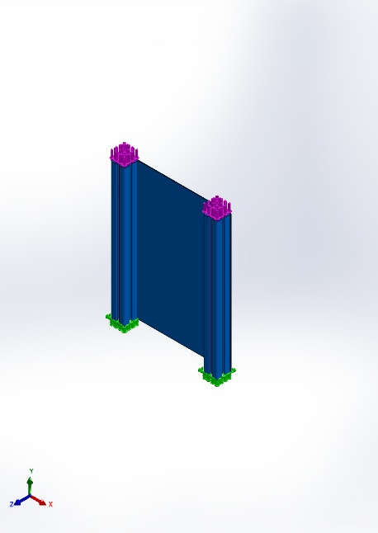 | Name: 6061 Alloy  Model type: Linear Elastic Isotropic  Default failure criterion: Unknown  Yield strength: 5.51485e+07 N/m^2  Tensile strength: 1.24084e+08 N/m^2  Elastic modulus: 6.9e+10 N/m^2  Poisson's ratio: 0.33  Mass density: 2,700 kg/m^3  Shear modulus: 2.6e+10 N/m^2  Thermal expansion coefficient: 2.4e-05 /Kelvin | SolidBody 1(Split Line1)(4040_sim-1),  SolidBody 1(Split Line1)(4040_sim-2),  SolidBody 1(Split Line1)(support plate_sim_4bolts_2mm-1)
Curve Data:N/A

Loads and Fixtures
Fixture name | Fixture Image | Fixture Details
Fixed-1 | 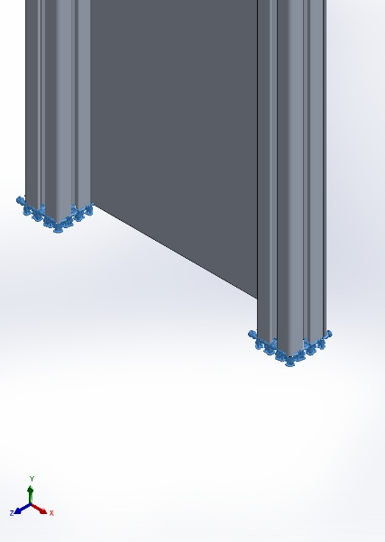 | Entities: 2 face(s)  Type: Fixed Geometry
Resultant Forces
Components | X | Y | Z | Resultant
Reaction force(N) | -1.13991 | 316.076 | 0.674979 | 316.079
Reaction Moment(N.m) | 0 | 0 | 0 | 0

Load name | Load Image | Load Details
Force-1 | 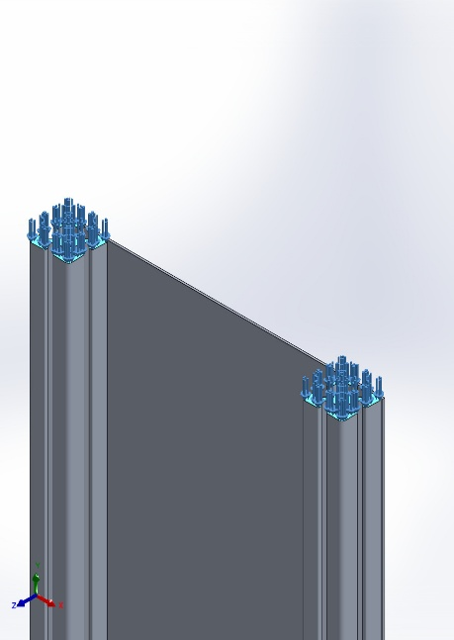 | Entities: 2 face(s)  Type: Apply normal force  Value: 100 N

Connector Definitions
No Data

Interaction Information

Interaction | Interaction Image | Interaction Properties
Local Interaction-1 | 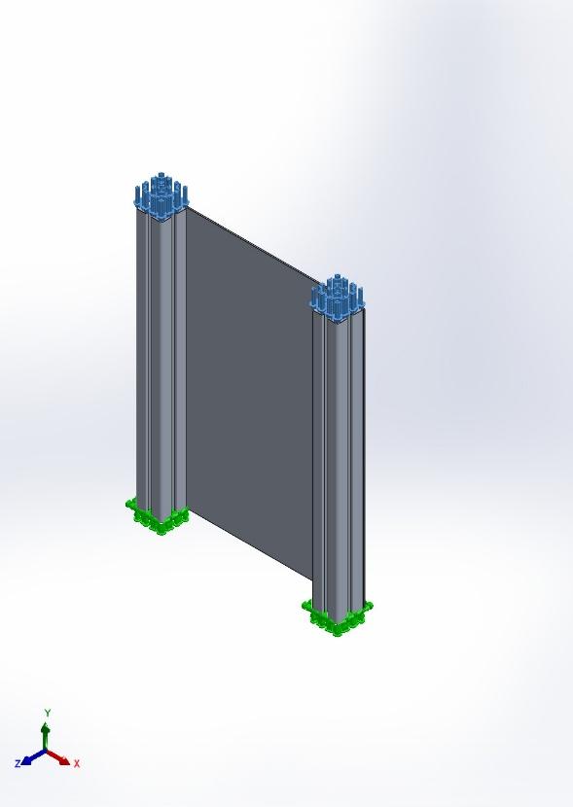 | Type: Bonded interaction pair  Entities: 8 face(s)
Global Interaction | 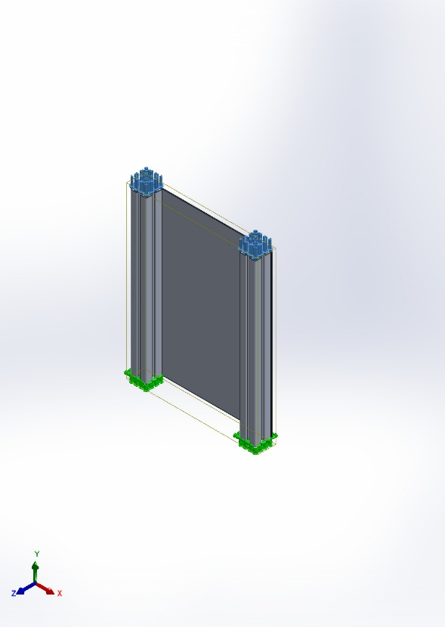 | Type: Bonded  Components: 1 component(s)  Options: Independent mesh

Mesh information
Mesh type | Solid Mesh
Mesher Used: | Blended curvature-based mesh
Jacobian points for High quality mesh | 16 Points
Maximum element size | 29.0804 mm
Minimum element size | 1.45402 mm
Mesh Quality | High
Remesh failed parts independently | Off
Reuse mesh for identical parts in an assembly (Blended curvature-based mesher only) | Off

Mesh information - Details
Total Nodes | 1341954
Total Elements | 870443
Maximum Aspect Ratio | 16.597
% of elements with Aspect Ratio < 3 | 99.6
Percentage of elements with Aspect Ratio > 10 | 0.0931
Percentage of distorted elements | 0
Time to complete mesh(hh;mm;ss): | 00:00:26
Computer name: | JNTES

Mesh Quality Plots
Name | Type | Min | Max
Quality1 | Mesh | - | -
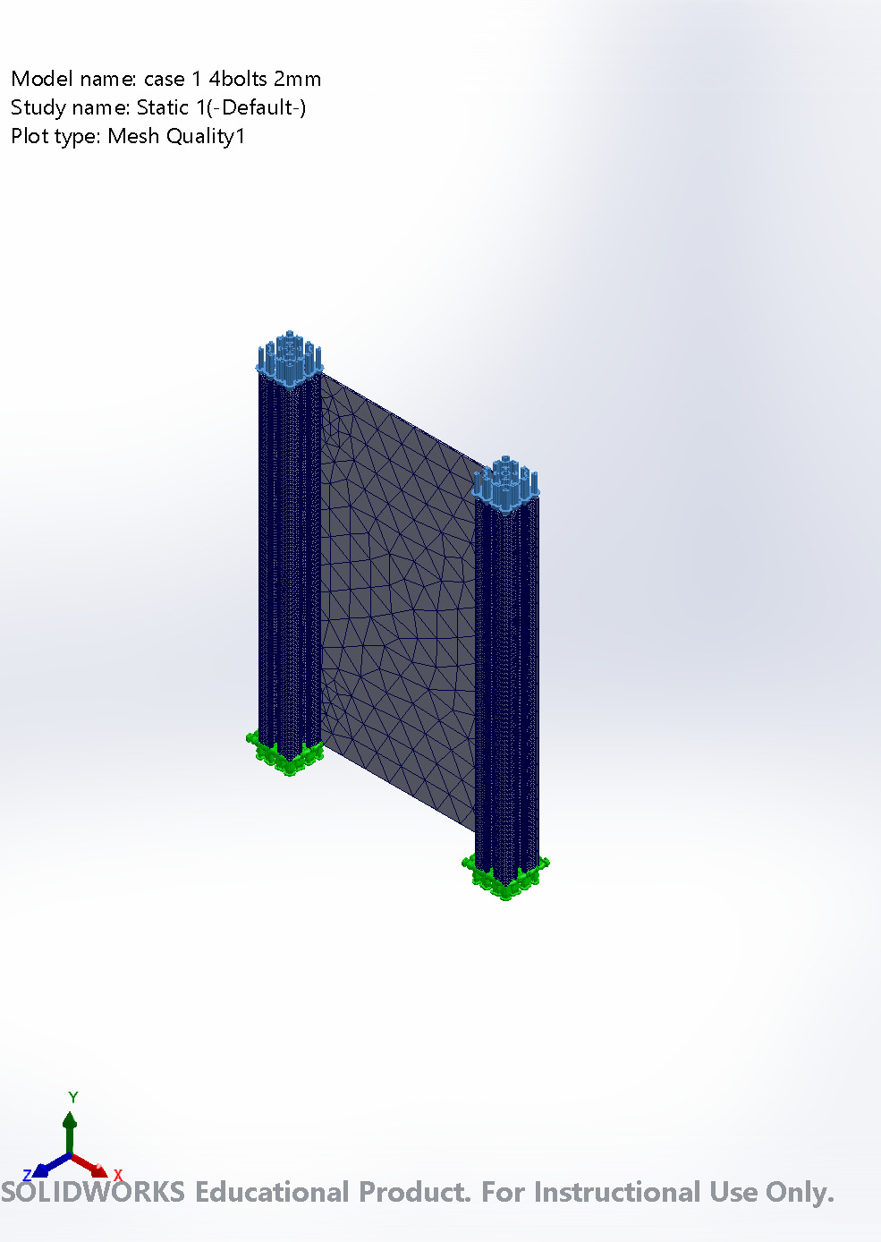
case 1 4bolts 2mm-Static 1-Quality-Quality1

Sensor Details
No Data

Resultant Forces

Reaction forces
Selection set | Units | Sum X | Sum Y | Sum Z | Resultant
Entire Model | N | -1.13991 | 316.076 | 0.674979 | 316.079

Reaction Moments
Selection set | Units | Sum X | Sum Y | Sum Z | Resultant
Entire Model | N.m | 0 | 0 | 0 | 0

Free body forces
Selection set | Units | Sum X | Sum Y | Sum Z | Resultant
Entire Model | N | 0.561494 | -2.42499 | 59.7269 | 59.7788

Free body moments
Selection set | Units | Sum X | Sum Y | Sum Z | Resultant
Entire Model | N.m | 0 | 0 | 0 | 1e-33

Beams
No Data

Study Results

Name | Type | Min | Max
Stress1 | VON: von Mises Stress | 1.265e+03N/m^2  Node: 1336968 | 3.782e+05N/m^2  Node: 33697
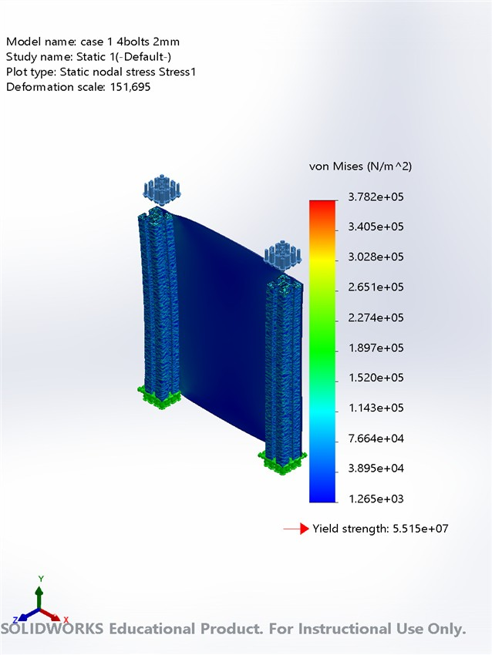
case 1 4bolts 2mm-Static 1-Stress-Stress1

Name | Type | Min | Max
Displacement1 | URES: Resultant Displacement | 0.000e+00mm  Node: 7 | 2.716e-04mm  Node: 514035
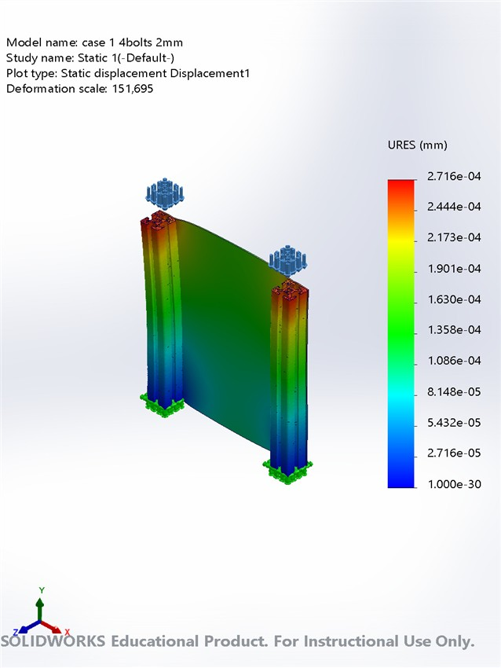
case 1 4bolts 2mm-Static 1-Displacement-Displacement1

Name | Type | Min | Max
Strain1 | ESTRN: Equivalent Strain | 1.102e-09  Element: 2591 | 2.857e-06  Element: 509723
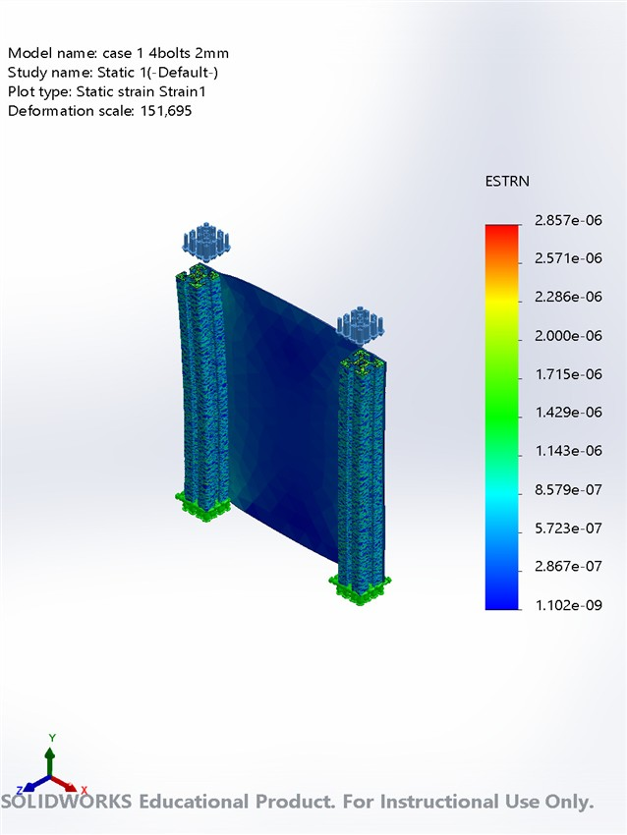
case 1 4bolts 2mm-Static 1-Strain-Strain1

Name | Type
Displacement1{1} | Deformed shape
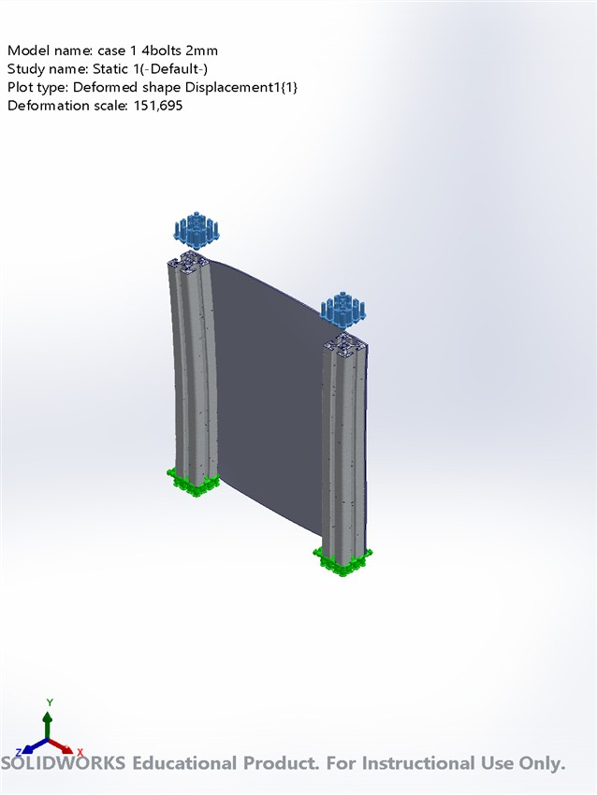
case 1 4bolts 2mm-Static 1-Displacement-Displacement1{1}

Conclusion

